**PREDICTING HOUSE PRICES USING MACHINE LEARNING**

**Abstract:**

**House price prediction is a critical task in the real estate industry, aiding buyers, sellers, and investors in making informed decisions. Machine learning models have gained popularity in recent years for their ability to analyze a myriad of factors affecting property values. In this paper, we present a comprehensive framework for house price prediction using machine learning techniques, organized into distinct modules to enhance model accuracy and interpretability.**

**Module 1: Data Acquisition and Preprocessing**

**This module focuses on collecting and cleaning the dataset. We gather a diverse set of features, including property attributes (e.g., square footage, number of bedrooms and bathrooms), neighborhood information (e.g., crime rates, school quality), and economic indicators (e.g., unemployment rates, inflation), ensuring a rich dataset for analysis. Data preprocessing techniques such as missing value imputation, outlier handling, and feature scaling are employed to prepare the data for modeling.**

**Module 2: Feature Selection and Engineering**

**Feature selection methods are applied to identify the most relevant features, reducing dimensionality and improving model efficiency. Additionally, feature engineering techniques are employed to create new informative features, such as price per square foot or neighborhood-specific metrics, enhancing the model's predictive power.**

**Module 3: Model Selection**

**We evaluate a range of machine learning algorithms, including linear regression, decision trees, random forests, support vector machines, and gradient boosting, to determine the most suitable model for house price prediction. Hyperparameter tuning is performed to optimize each model's performance.**

**Module 4: Model Evaluation**

**To assess model performance, we employ various evaluation metrics such as mean squared error (MSE), root mean squared error (RMSE), and R-squared. Cross-validation techniques are used to ensure the model's generalization capability. Interpretability methods, such as feature importance analysis and SHAP values, are utilized to gain insights into the model's decision-making process.**

**Module 5: Deployment and Monitoring**

**The final trained model is deployed in a user-friendly interface or integrated into a real estate platform to provide accurate price predictions for users. Continuous monitoring and updates are implemented to adapt to changing market conditions and maintain model reliability.**

**Data Source:**

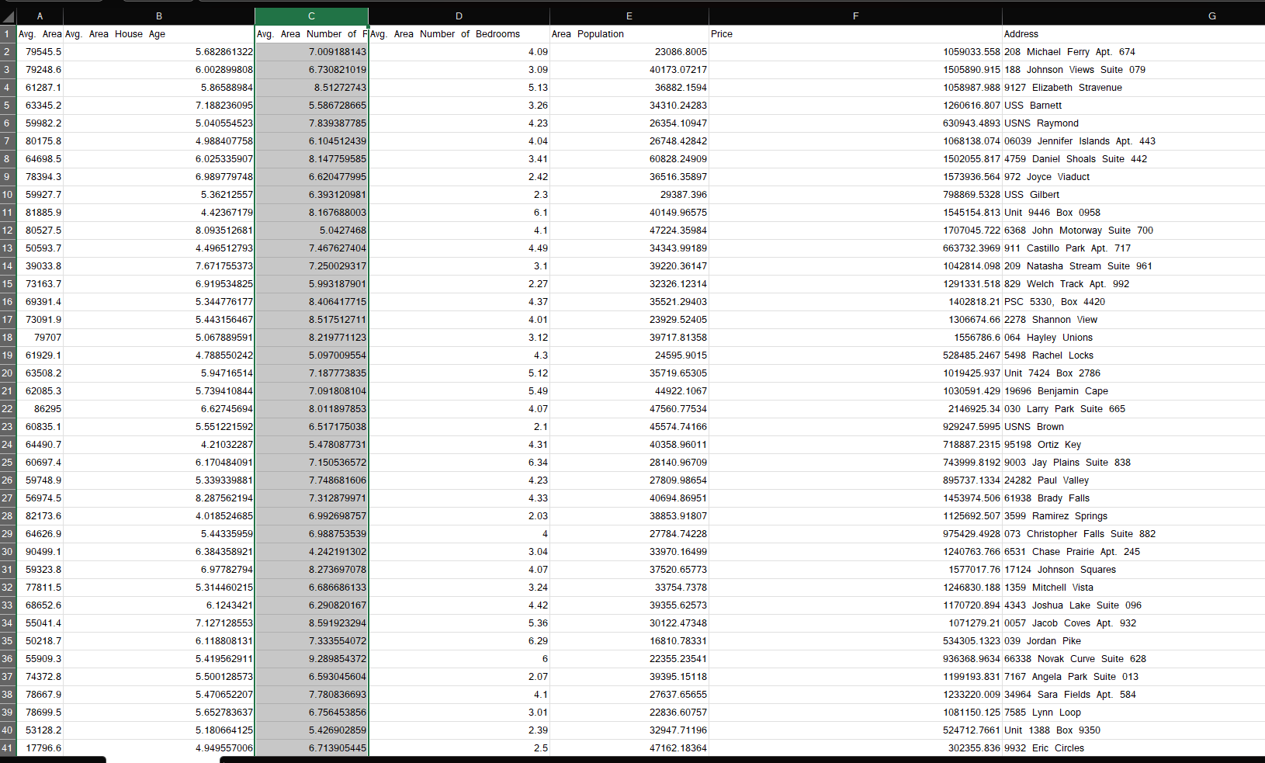

**Data Preprocessing:**

**Data preprocessing is a critical step in the house price prediction AI model development pipeline. It involves the cleaning and transformation of raw housing data to make it suitable for training and evaluating machine learning models.**

**1.Data Collection: The process begins by gathering data related to houses. This data can come from various sources, including real estate websites, government records, or surveys. It typically includes information such as house features (e.g., size, number of bedrooms, bathrooms), location (e.g., neighborhood, city), historical pricing data, and other relevant attributes.**

**2.Data Cleaning &Handling Missing Values: Real-world data often contains missing values. These gaps need to be addressed. Strategies include removing rows with missing values, imputing missing values with the mean or median, or using more advanced imputation techniques.**

**3.** **Data Visualization and Exploration: Throughout the preprocessing phase, it's essential to visualize and explore the data to gain insights, identify patterns, and validate assumptions. Visualization tools like histograms, scatter plots, and correlation matrices are helpful.4**

**4.** **Feature Engineering: Feature Selection: Not all features may be relevant to predicting house prices. Feature selection techniques help identify the most important attributes and reduce dimensionality.**

**Categorical Data Encoding: Machine learning models require numerical input, so categorical variables like "neighborhood" need to be encoded into numerical values using techniques like one-hot encoding or label encoding.**

**Feature Scaling: Features often have different scales. Scaling ensures that all features contribute equally to the model and helps algorithms converge faster. Common scaling methods include standardization and normalization.**

**Conclusion:**

**In conclusion, our modular framework for house price prediction using machine learning combines data acquisition, preprocessing, feature engineering, model selection, evaluation, and deployment into a coherent pipeline. This approach not only enhances prediction accuracy but also allows for a deeper understanding of the factors influencing house prices, ultimately benefiting stakeholders in the real estate industry**